**CS 203 Object Oriented Design**

**Lab 04**

**Objectives:**

* Learn how to write Java graphical applications.
* Use Java graph related classes to draw a graph.
* Have fun.

**Basic Assignment:**

Use provided classes to draw a graph as follows.

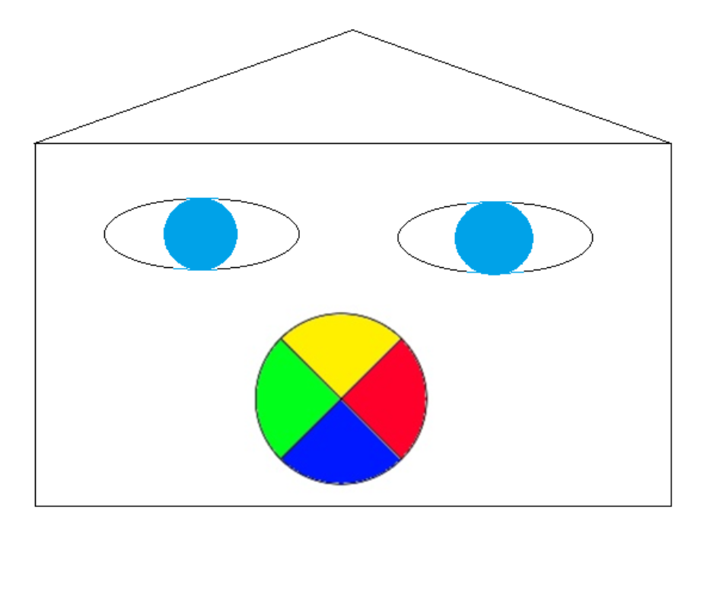

**Stretch Assignment:**

If you finish the assignment above, try to think how you can move the graph easily as a whole.